**Practice Project**

**MS SQL**

**Aim:**

To create tables and indexes for storing students, subjects and classes data using SQL Server.

**Github link:**

**Procedure:**

* Create a database school
* Use database school.create tables student,class,subjects with primary keys
* Insert values into tables(student,class,subjects)
* Select * from tablename to see the tables with values.
* sp_help is executed with no arguments, summary information of objects of all types that exist in the current database is returned.

**Output:**

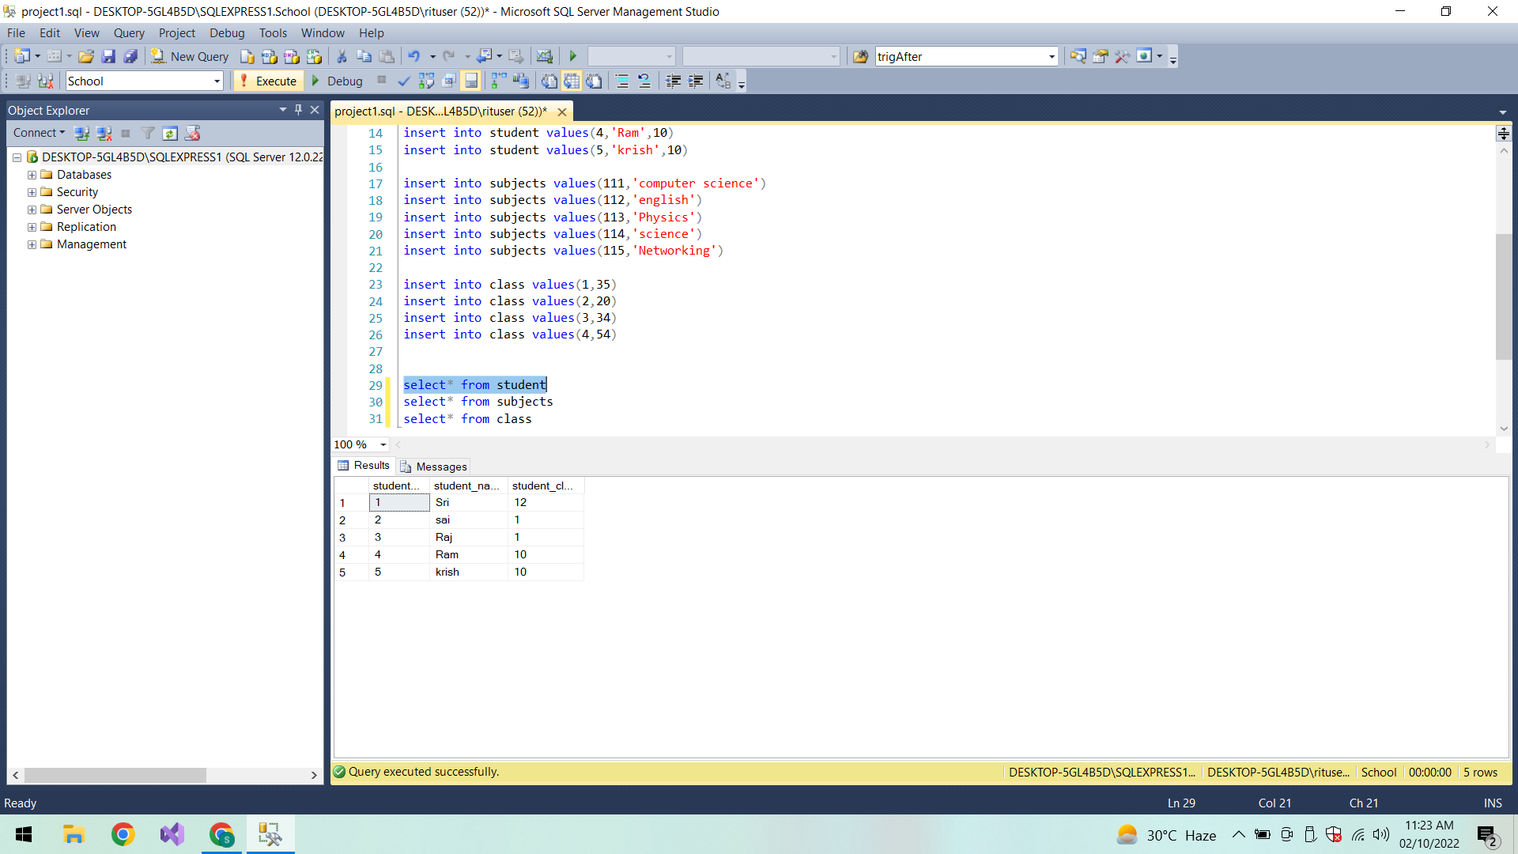

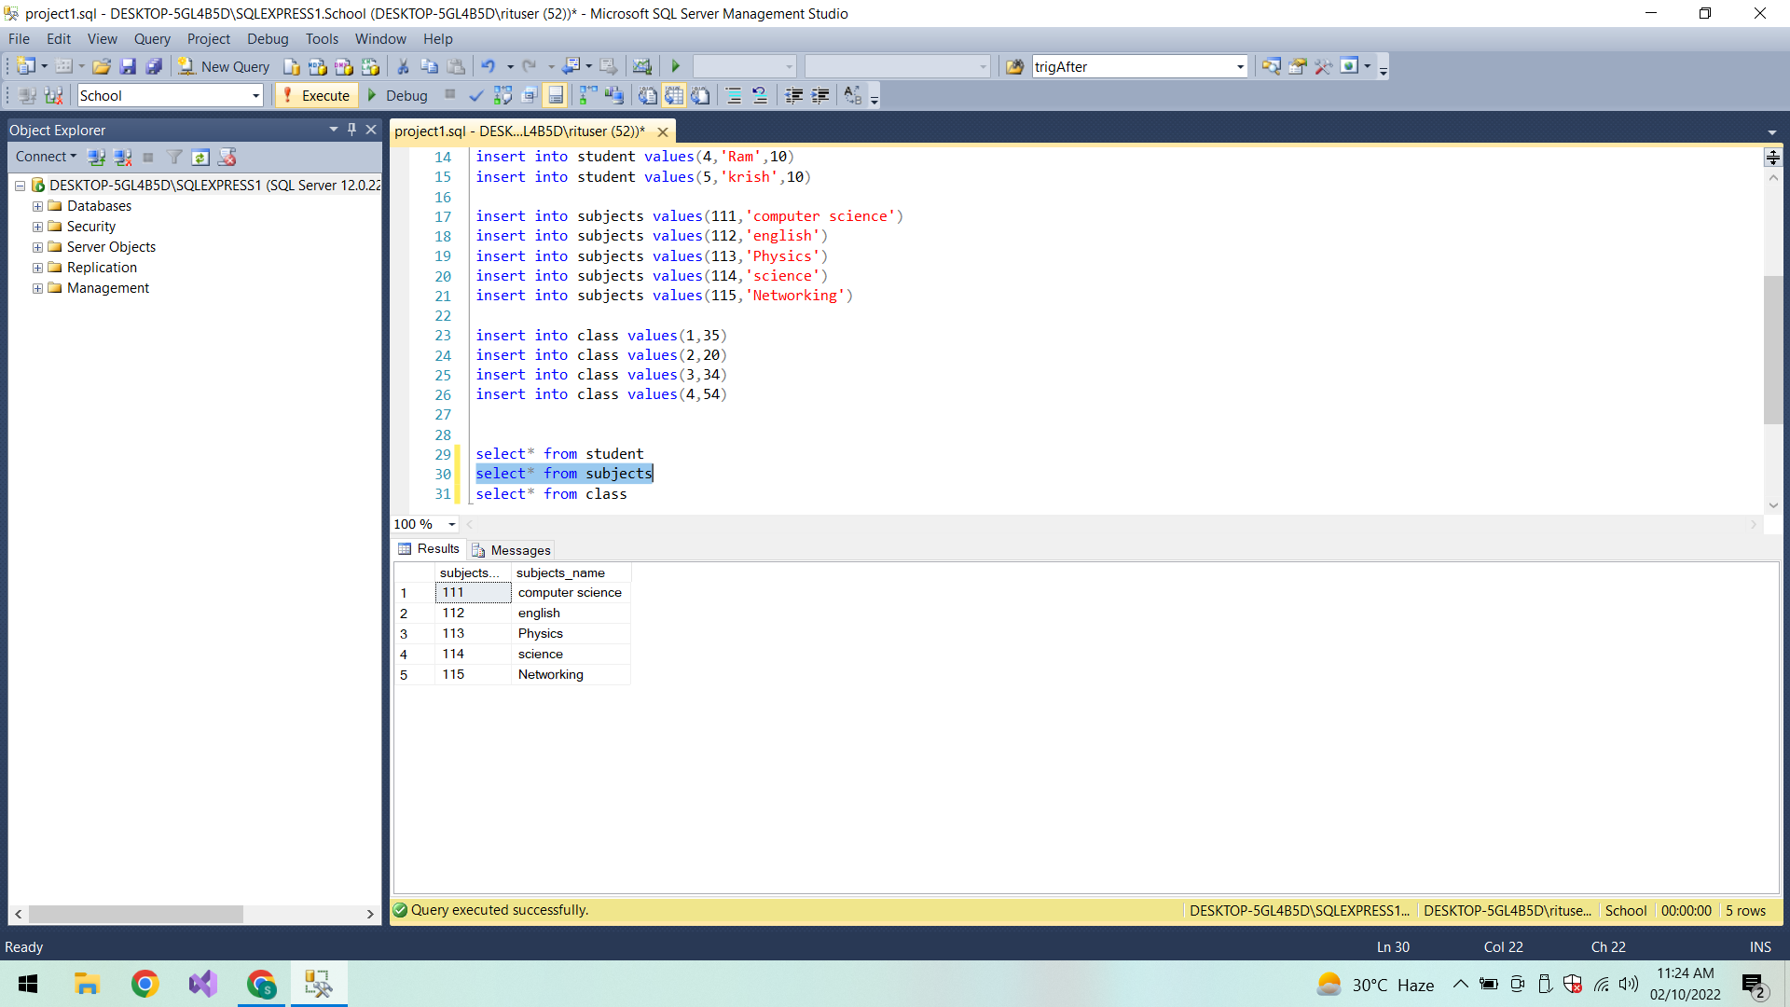

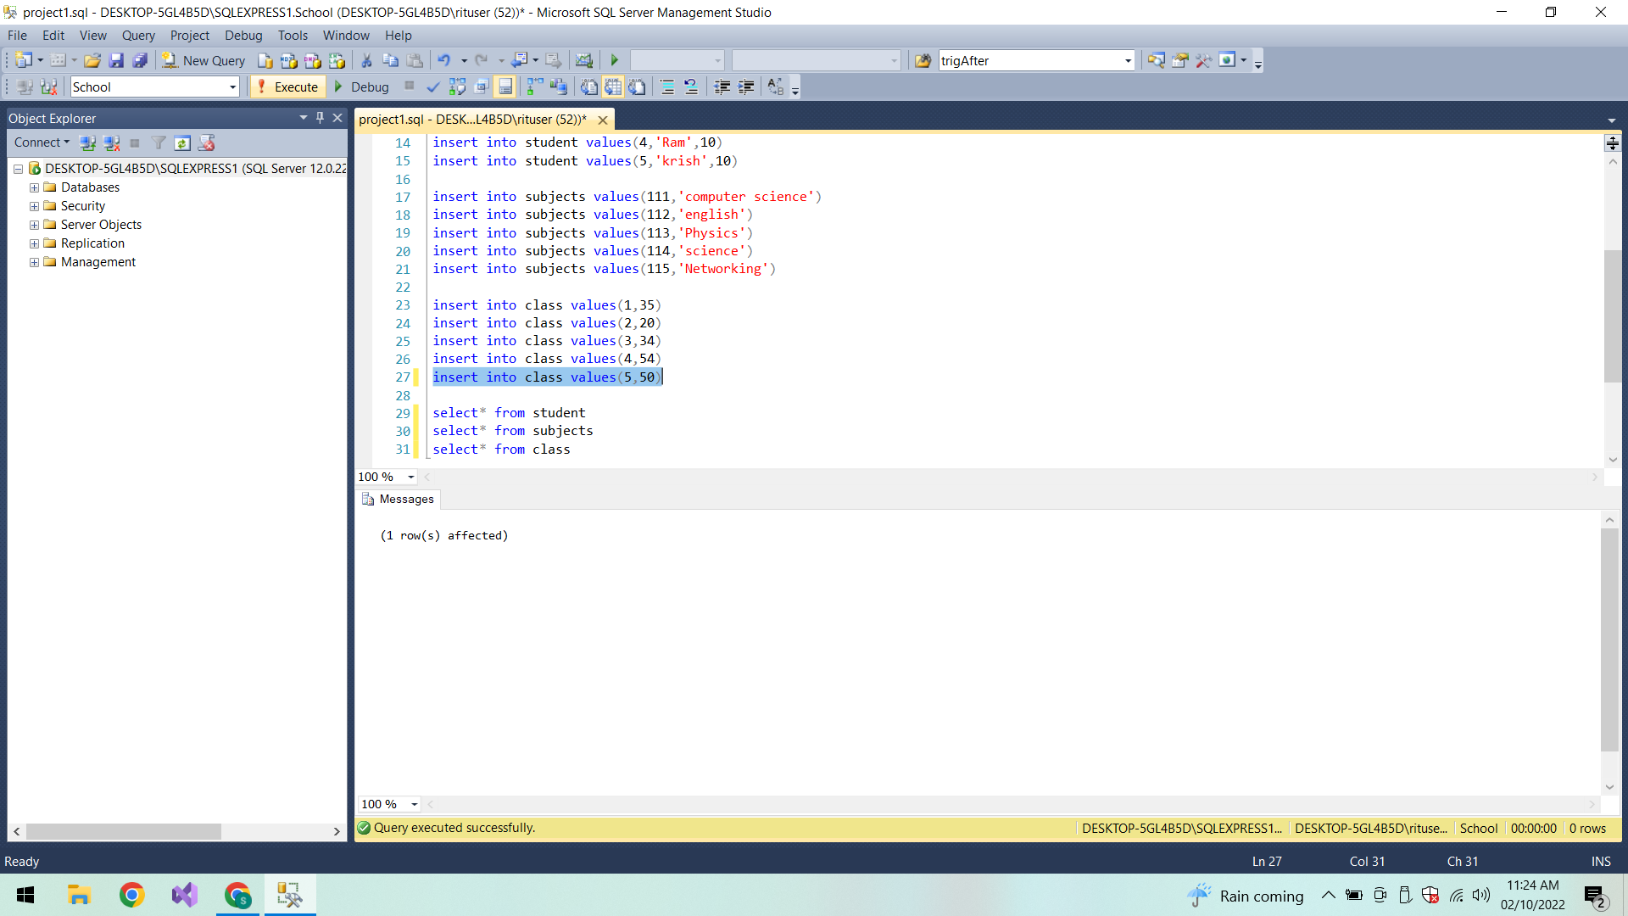

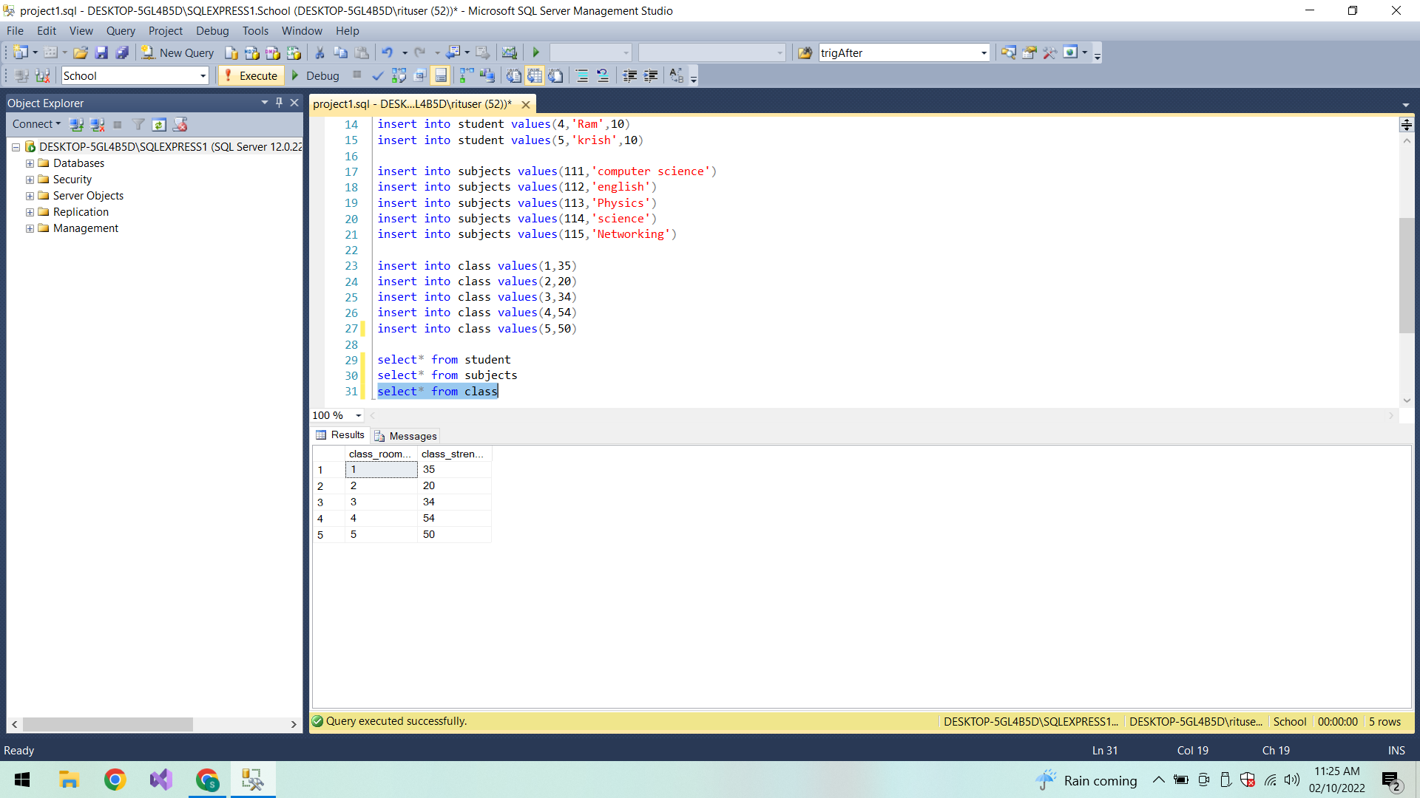

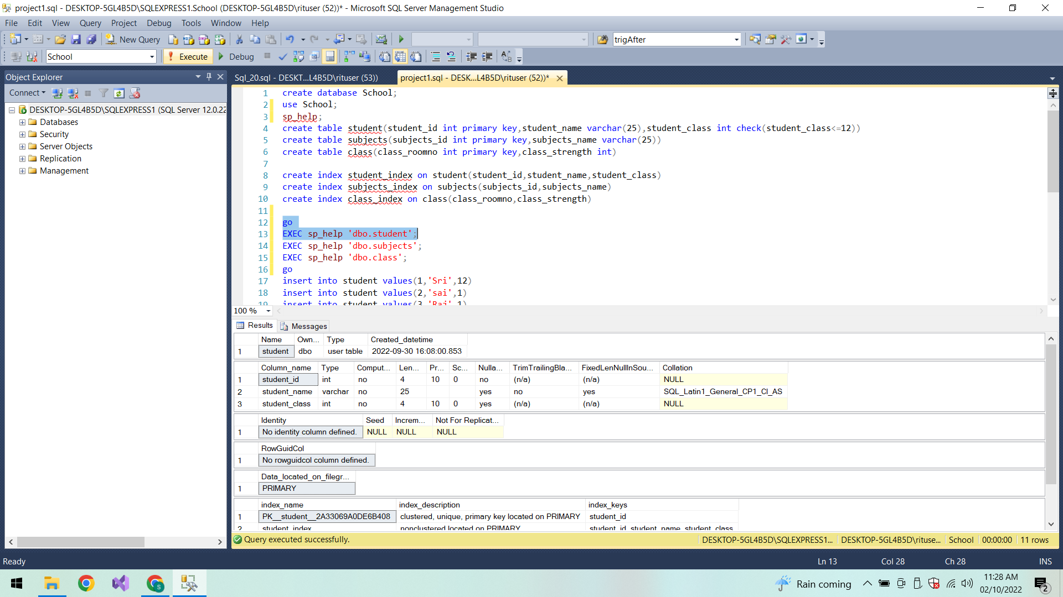

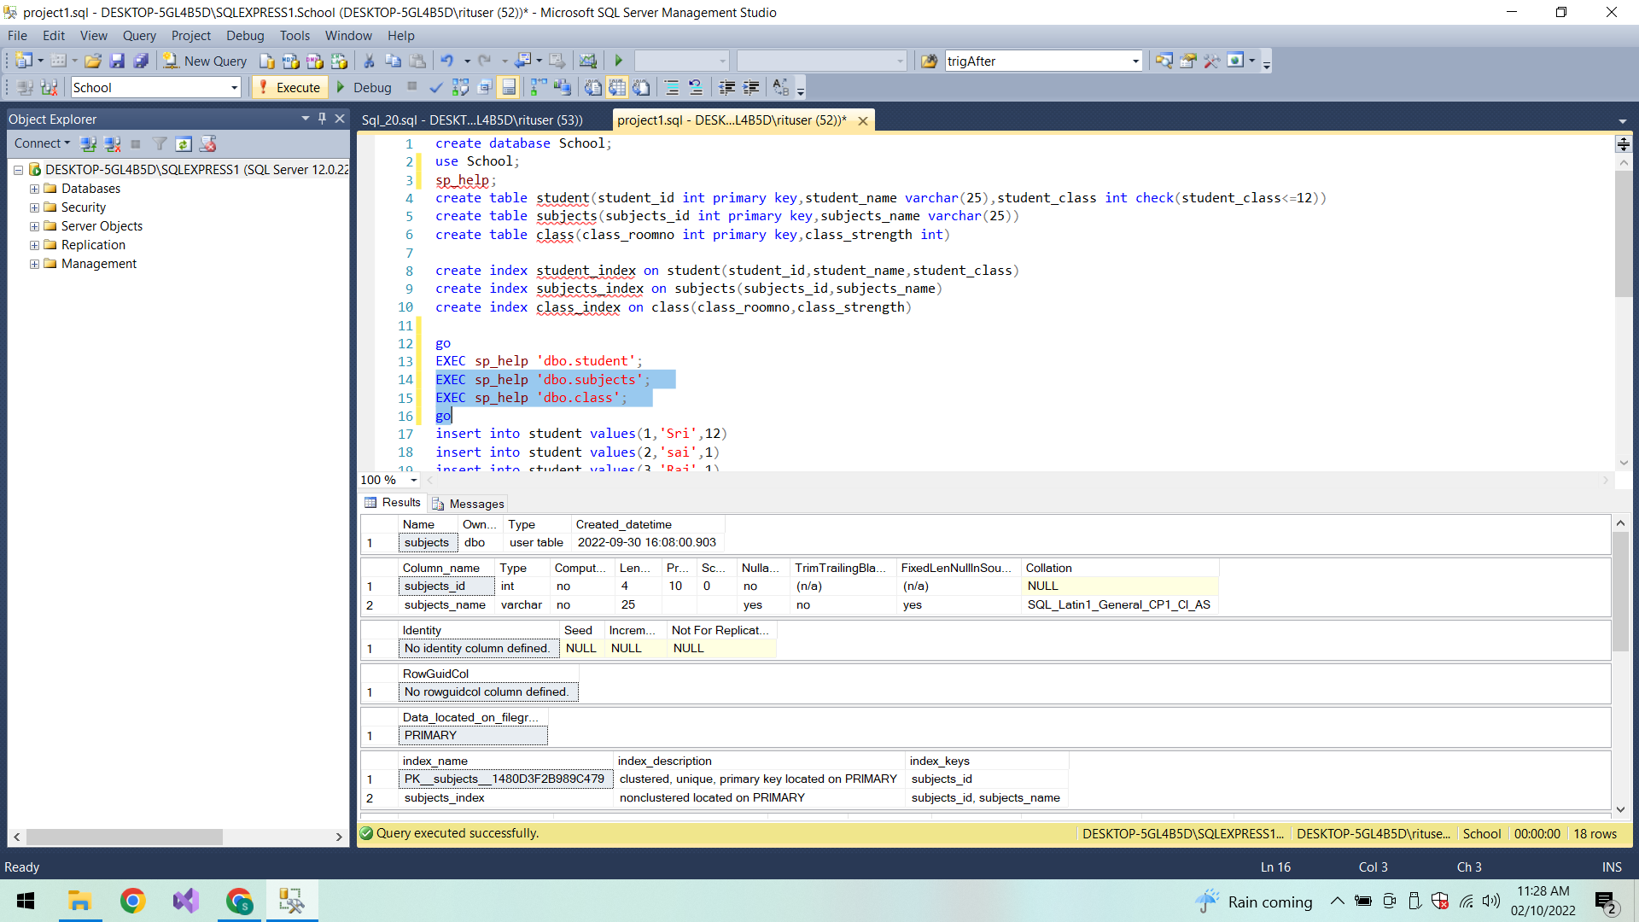

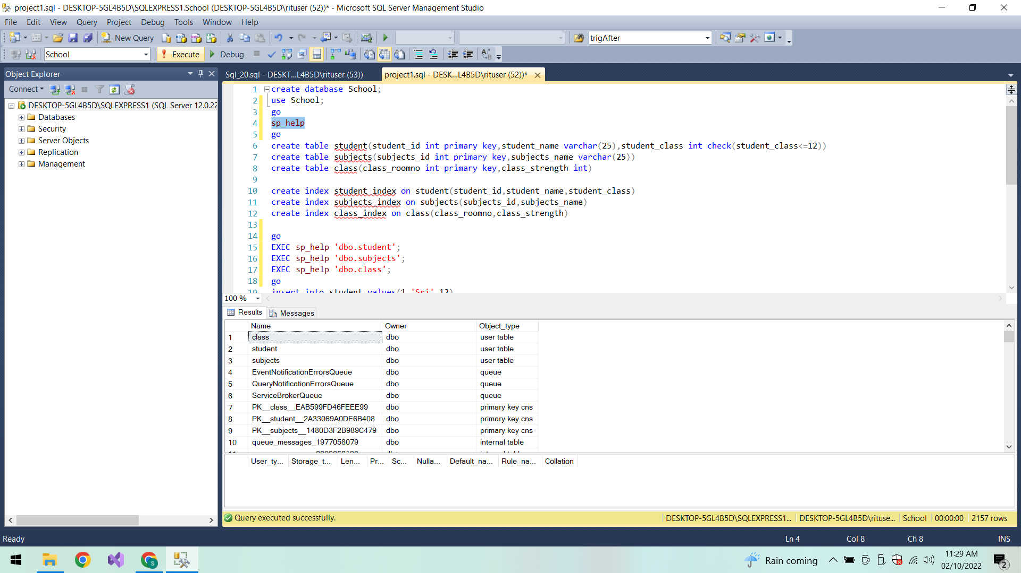

**Conclusion:**

Thus the tables and indexes are created and executed successfully.